**DAILY ONLINE ACTIVITIES SUMMARY**

|  |  |  |  |  |  |  |  |  |
| --- | --- | --- | --- | --- | --- | --- | --- | --- |
| **Date:** | 30/05/2020 | | | | | **Name:** | D Richard Franklin | |
| **Sem & Sec** | Fourth SEM section A | | | | | **USN:** | 4AL18CS020 | |
| **Online Test Summary** | | | | | | | | |
| **Subject** | | Data communication & Complex analysis, probability and statistical methods | | | | | | |
| **Max. Marks** | | 30, 30 | | **Score** | | | 28, 28 | |
| **Certification Course Summary** | | | | | | | | |
| **Course** | [Certified Kubernetes Administrator (CKA) with Practice Tests](https://www.udemy.com/course/certified-kubernetes-administrator-with-practice-tests/) | | | | | | | |
| **Certificate Provider** | | | Udemy | | **Duration** | | | 3 Hour |
| **Coding Challenges** | | | | | | | | |
| **Problem Statement:** 1. Stack operation using SLL  2. Round robin type of process scheduling | | | | | | | | |
| **Status:** Completed | | | | | | | | |
| **Uploaded the report in Github** | | | | | YES | | | |
| **If yes Repository name** | | | | | <https://github.com/richard3658/lockdown-coding> | | | |
| **Uploaded the report in slack** | | | | | YES | | | |

**Online Test Details:**

1. **Data communication:** The online test was from module 3 and 4 which was about bandwidth utilization, switching, error detection and correction, data link control, media access control. Introduction to data link layer and IPv4 & addressing sub netting. There were 30 questions and the duration was 45 minutes. The questions were optimal and were easy. The score that I got in the test is 28/30.
2. **Complex analysis, probability and statistical methods:** The online test was from module 3 which was about probability distribution. There were 20 questions where 10 was for 1 mark each and the remaining 10 for 2 marks each and the duration was 45 minutes. The questions were optimal and were easy. The score that I got in the test is 28/30.

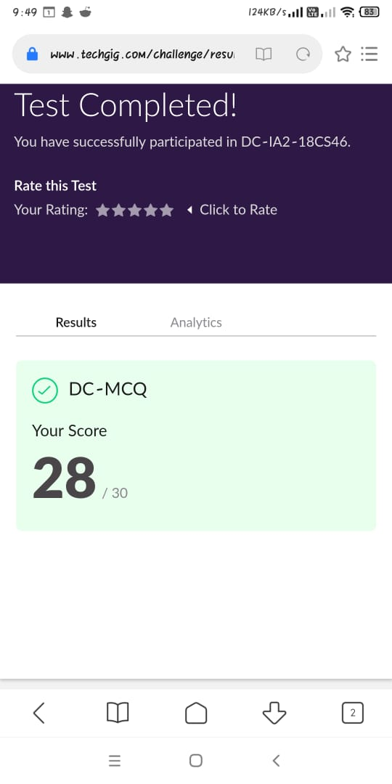 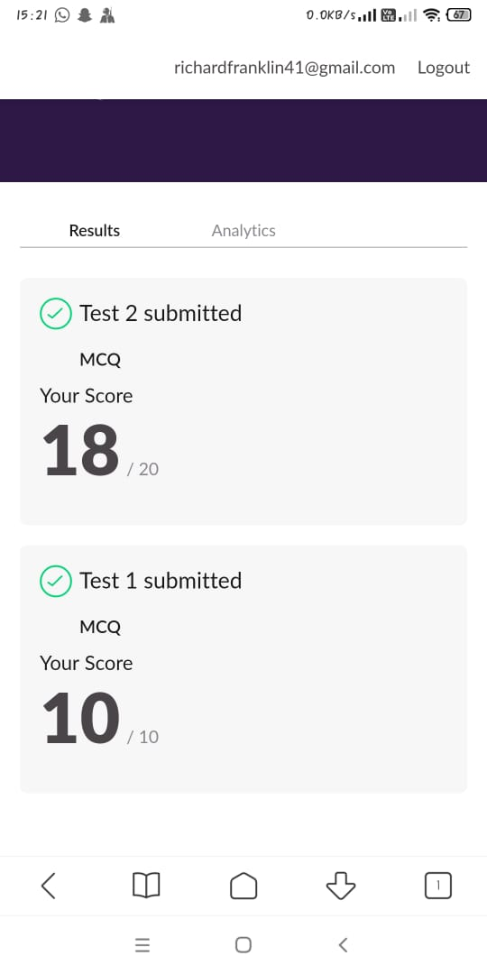

**Certification Course Details:**

**Name of the course**: [Certified Kubernetes Administrator (CKA) with Practice Tests](https://www.udemy.com/course/certified-kubernetes-administrator-with-practice-tests/)

**Certificate Provider**: Udemy

This course has 17 sections and the total duration is 15 hours.

In the twelfth day I went through the section of the course that explained about networking using kubernetes and how it’s different from other cloud computing techniques. Had also done few tasks given by them.

**Snapshot:**

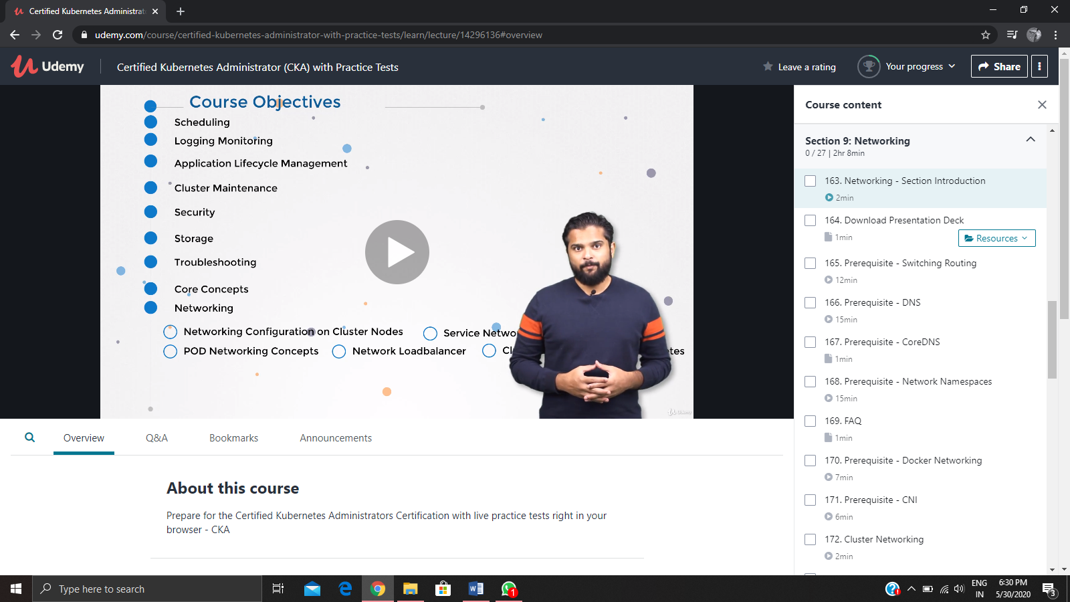

**Online Coding Details:**

Problem 1: (using C language) [Write a C Program to count Uppercase, Lowercase, special character and numeric values for a given String](https://github.com/orgs/alvas-education-foundation/teams/2nd-year/discussions/88)